Test Case Name | EAB525
Test Case Owner: | Maria Domniguez | Reviewed Date:
Date of last update: | 07/15/25 | Sign Off Date:
EB525 – WMS- WMS – Unable to arrange tiles in WMS

Description:
CS0004644342 - Unable to arrange tiles in WMS
Outline your issue:
In the upcoming release 2024.2 we can assign custom WMS main menus. I am able to add and remove the tiles, but I am unable to arrange them how I want. Is
there a way arrange the tiles on the main menu? Any help on this would be appreciated.
Thank you.

Solution
Rearrange WMS menus in the dashboard according to the session API response
Test Plan Outline:

Setup: Before executing this test case we need

- Authorization Keys
- Normal user.
- Superuser with full branch authorization

- Valid Menus
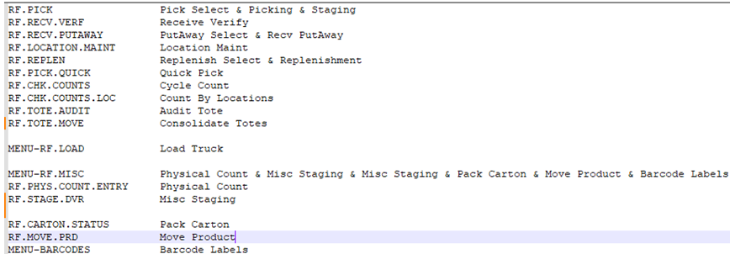

- WMS Menus.
- Login Eterm.
- Go to System, System Programming and select Program Editor option. (F2 < Alt – S < Alt - P)
- Enter MENU on File Name
- Enter the Menu name on Edit Program
- Hit Enter
- Select New
- Enter E option to Edit The Menu
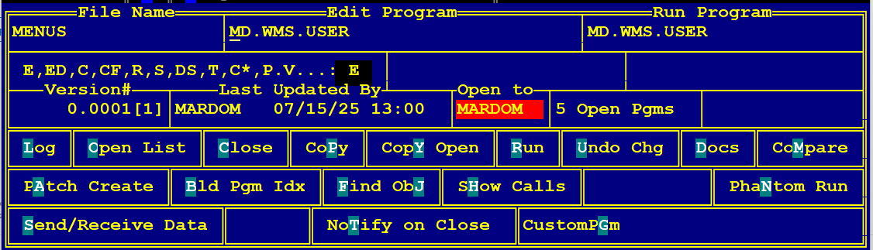

- Hit Enter
- Enter some menus from the valid Menus list
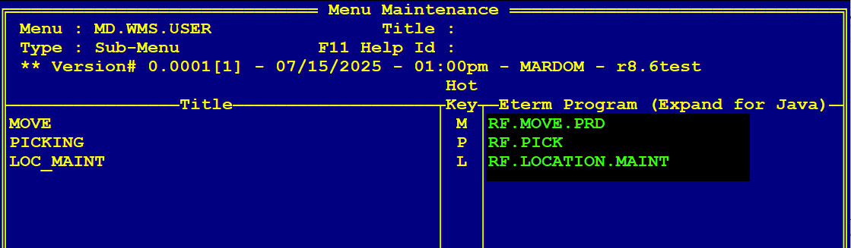

- Hit ESC
- Enter Y on the compile Menu prompt
- Create 3 different Wms Menus.
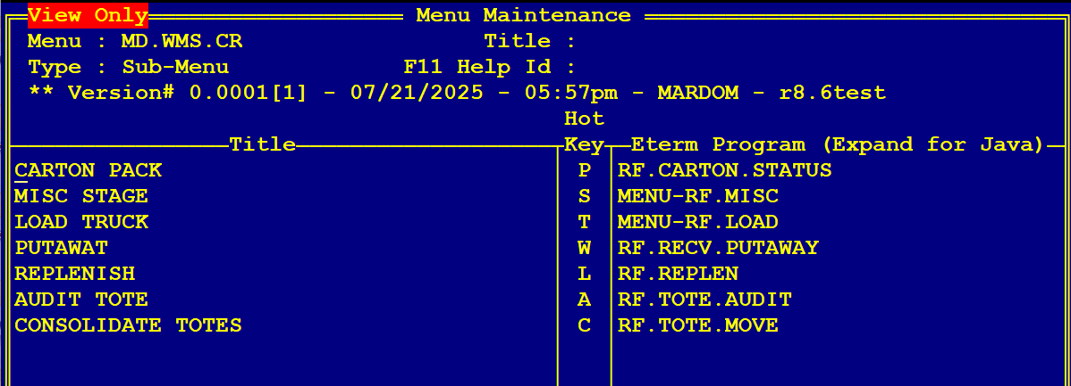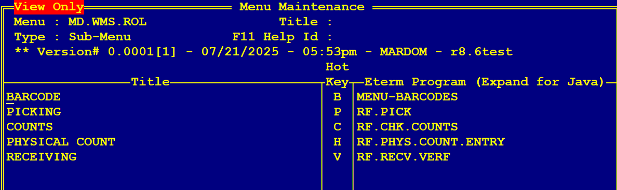

- CR WMS Menu Default set to Empty
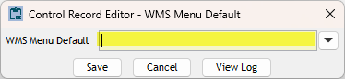
- User without Rol and WMS menu
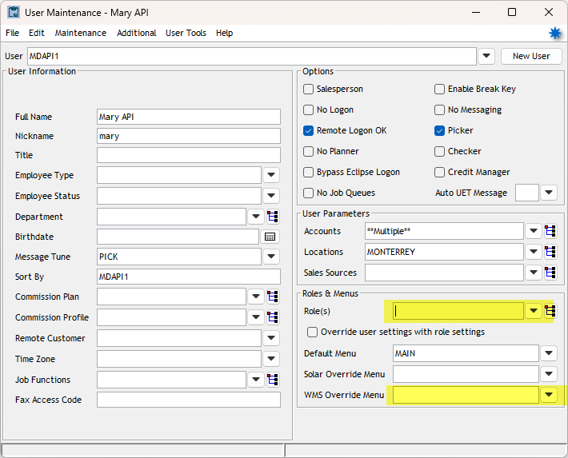
- Rol created with a menu assigned
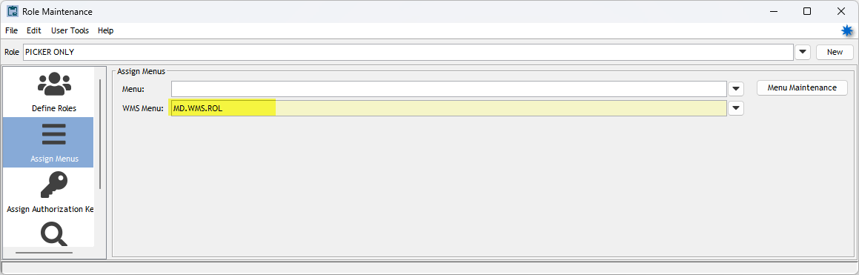

- Menu Priority.
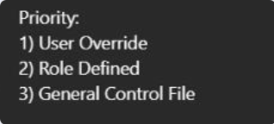

Test summary

# | Test description | Environment | Expected results
 | Verify a user without any WMS Menu assigned | WMS | Default RF.MAIN.MENU is displayed arranged as per API sort
 | Verify a user when only General Control File WMS Menu is defined | WMS | The WMS Menu set at General Control File is displayed as per API sort
 | Verify a user when Role with WMS Menu is defined | WMS | The WMS Menu set at Role is displayed and arranged according to the API sort
 | Verify a user with WMS Override Menu assigned | WMS | WMS Override Menu displayed and arranged as per API sort
 | Verify a user with WMS Menu assigned but menu has invalid options | WMS | Only the valid menu options are displayed and arranged as per API sort
 | Verify user with BARCODE submenus assigned individually | WMS | Only assigned submenus are displayed in BARCODE menu but they will not be arranged as API sort
 | Verify WMS dashboard when picker is changed | WMS | WMS menu dashboard is displayed as per logged Session user

Testing Steps:
R8.6TEST (WMS)

Scenario 1. Verify a user without any WMS Menu assigned. Here we are going to validate that not having any WMS assigned will default to RF main menu and it will be arranged as API sort.

Steps to reproduce:

- Login to Swagger: https://hyprod:7001/swagger/index.html
- Execute POST Session for the user:
URL: /Sessions
Request body:
{
"username": "user",
"password": "password",
}
- Verify in the response wmsMenu field
- Login to WMS with same user
- Compare API response sort with WMS Menu sort
"wmsMenu": [  {  "id": "PickSelect"  },  {  "id": "Picking"  },  {  "id": "Staging"  },  {  "id": "RecvVerify"  },  {  "id": "PutawaySelect"  },  {  "id": "RecvPutAway"  },  {  "id": "LocationMaint"  },  {  "id": "ReplenishSelect"  },  {  "id": "Replenishment"  },  {  "id": "QuickPick"  },  {  "id": "CycleCount"  },  {  "id": "CountByLocations"  },  {  "id": "AuditTote"  },  {  "id": "ConsolidateTotes"  },  {  "id": "LoadTruck"  },  {  "id": "PhysicalCount"  },  {  "id": "MiscStaging"  },  {  "id": "PackCarton"  },  {  "id": "MoveProduct"  },  {  "id": "ProductBarcodeLabels"  },  {  "id": "ToteLotBarcodeLabels"  },  {  "id": "ShelfBarcodeLabels"  }  ] | 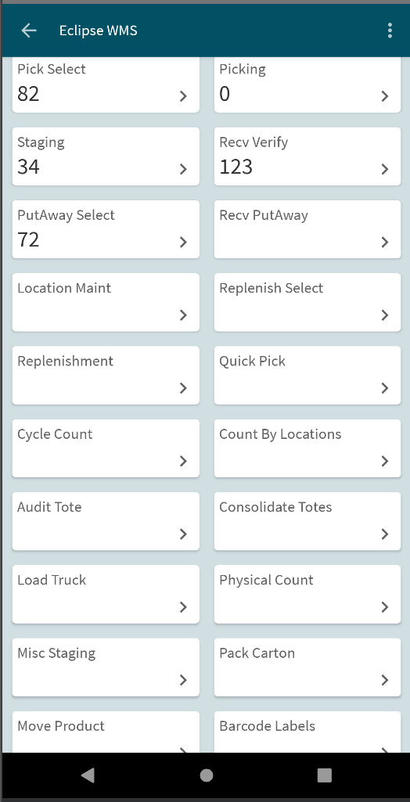
Expected Result: Default RF.MAIN.MENU is displayed and arranged as per API sort.

Scenario 2. Verify a user when only General Control File WMS Menu is defined: Here we are going to validate that having a Menu assigned on the WMS Menu Default CR will display that menu on WMS and it will be arranged as API sort.

Steps to reproduce:

- Login to Solar
- From Main menu go to System>System Files>Control Maintenance
- Open WMS Menu Default CR
- Assign a Menu from setup
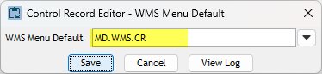
- Login to Swagger: https://hyprod:7001/swagger/index.html
- Execute POST Session for the user:
URL: /Sessions
Request body:
{
"username": "user",
"password": "password",
}
- Verify in the response wmsMenu field
- Login to WMS with same user
- Compare API response sort with WMS Menu
"wmsMenu": [  {  "id": "PackCarton"  },  {  "id": "PhysicalCount"  },  {  "id": "MiscStaging"  },  {  "id": "PackCarton"  },  {  "id": "MoveProduct"  },  {  "id": "ProductBarcodeLabels"  },  {  "id": "ToteLotBarcodeLabels"  },  {  "id": "ShelfBarcodeLabels"  },  {  "id": "LoadTruck"  },  {  "id": "PutawaySelect"  },  {  "id": "RecvPutAway"  },  {  "id": "ReplenishSelect"  },  {  "id": "Replenishment"  },  {  "id": "AuditTote"  },  {  "id": "ConsolidateTotes"  }  ] | 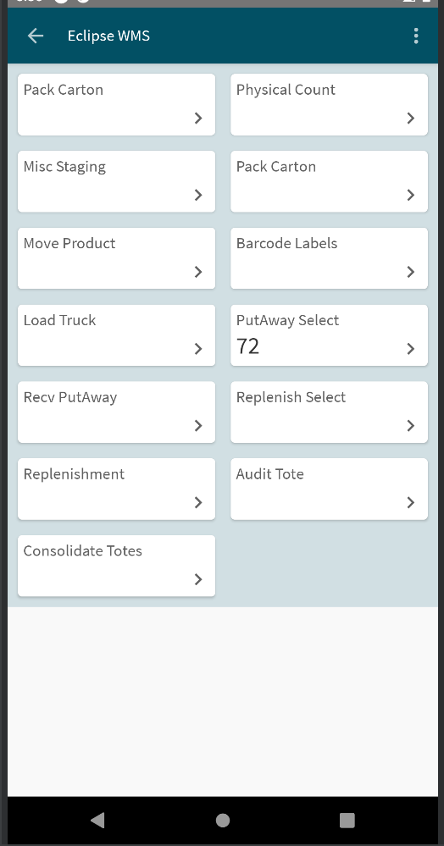
Expected Result: **General Control File Menu is displayed and arranged as per API sort.**

Scenario 3. Verify a user when Role with WMS Menu is defined: Here we are going to validate that having a Rol with WMS menu assigned will display that menu on WMS and it will be arranged as API sort.

Steps to reproduce:

- Login to Solar
- Go to User Maintenance and open the user
- Assign the Rol having the WMS menu from setup
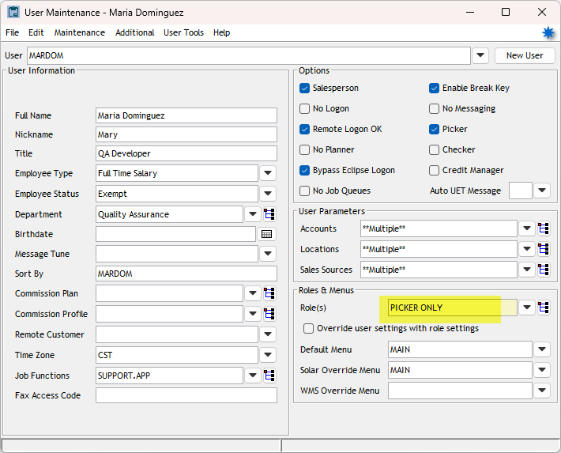
- Repeat steps 1-5 from scenario 1
"wmsMenu": [  {  "id": "ProductBarcodeLabels"  },  {  "id": "ToteLotBarcodeLabels"  },  {  "id": "ShelfBarcodeLabels"  },  {  "id": "PickSelect"  },  {  "id": "Picking"  },  {  "id": "Staging"  },  {  "id": "CycleCount"  },  {  "id": "PhysicalCount"  },  {  "id": "RecvVerify"  }  ] | 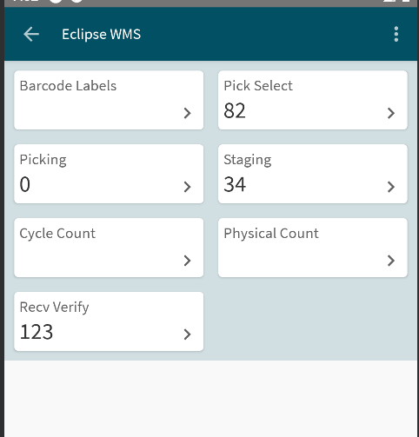  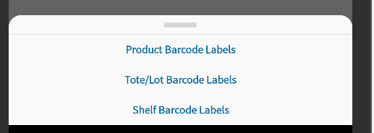
Expected Result: **WMS Menu assigned to the Rol is displayed and arranged as per API sort**

Scenario 4. Verify a user with WMS Override Menu assigned: Here we are going to validate that having a WMS Override menu assigned will display that menu on WMS and it will be arranged as API sort.

Steps to reproduce:

- Log into WMS.
- Go to User Maintenance and open the user
- Assign a WMS Override Menu from setup
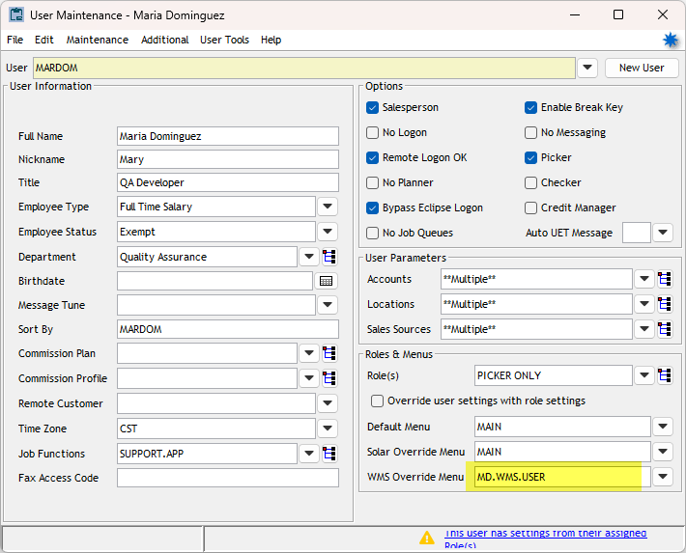
- Repeat steps 1-5 from scenario 1
"wmsMenu": [  {  "id": "MoveProduct"  },  {  "id": "PickSelect"  },  {  "id": "Picking"  },  {  "id": "Staging"  },  {  "id": "LocationMaint"  }  ] | 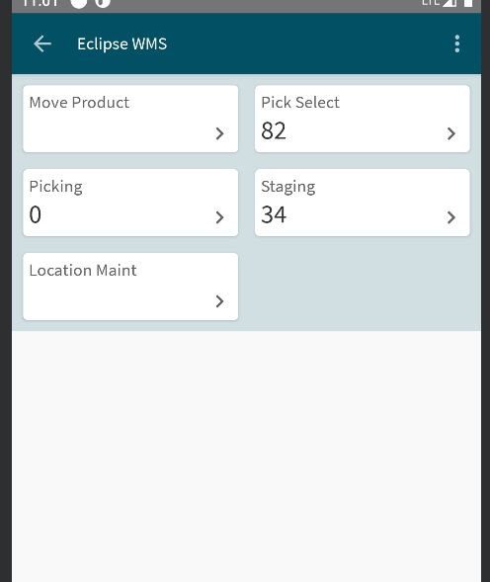
Expected Result: **WMS Override Menu is displayed and arranged as per API sort.**

Scenario 5. Verify a user with WMS Menu assigned but menu has invalid options. Here we are going to validate that having a WMS Override menu assigned with invalid options, will display only valid menus on WMS and it will be arranged as API sort.

Steps to reproduce:

- Login to Solar
- Go to System>System Files>User Controls>Menu Maintenance
- Open the WMs Override Menu assigned to the user on scenario 4
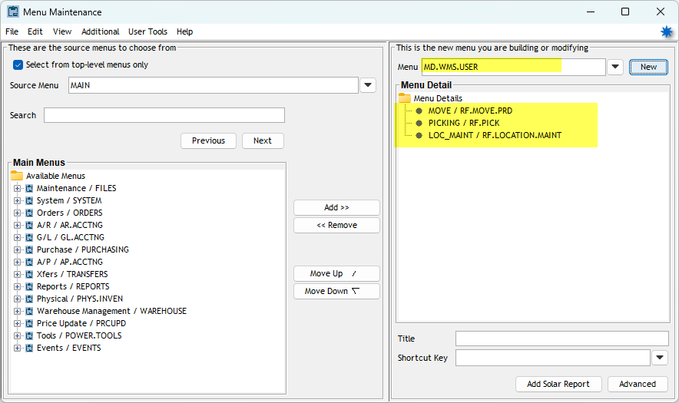
- Assign Invalid Menus from Main Menus list using Add button
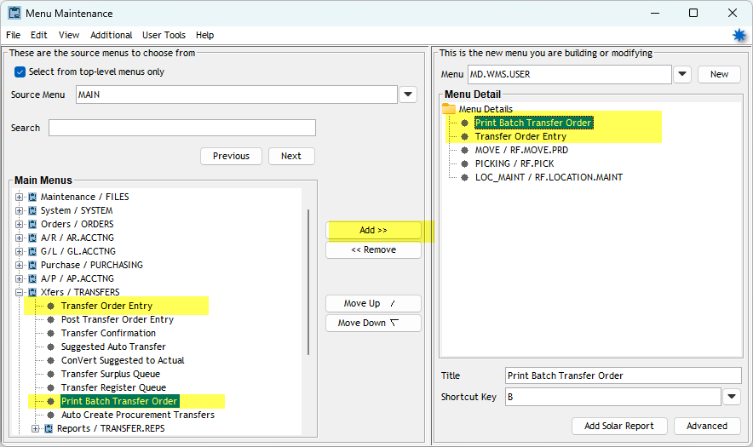
- Save changes
- Repeat steps 1-5 from scenario 1
"wmsMenu": [
{
"id": "MoveProduct"
},
{
"id": "PickSelect"
},
{
"id": "Picking"
},
{
"id": "Staging"
},
{
"id": "LocationMaint"
}
]
Expected Result: **Only valid RF options from WMS Override Menu are displayed and arranged as per API sort.**

Scenario 6. Verify user with BARCODE submenus assigned individually: Here we are going to validate that having a WMS Override menu assigned with Barcode submenus options added individually, will display BARCODE menu on WMS but submenu will not be arranged as API sort.

Steps to reproduce:

- Repeat steps 1-3 from scenario 5
- Remove invalid Menus
- Add 2 submenus from the Bar code Labels Menu using Add button
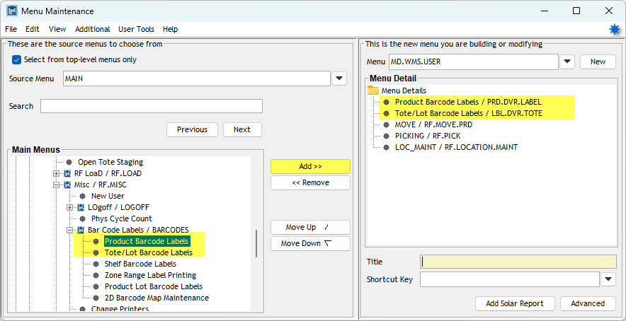
- SAve changes
Repeat steps 1-5 from scenario 1"wmsMenu": [  {  "id": "ProductBarcodeLabels"  },  {  "id": "ToteLotBarcodeLabels"  },  {  "id": "MoveProduct"  },  {  "id": "PickSelect"  },  {  "id": "Picking"  },  {  "id": "Staging"  },  {  "id": "LocationMaint"  }  ] | 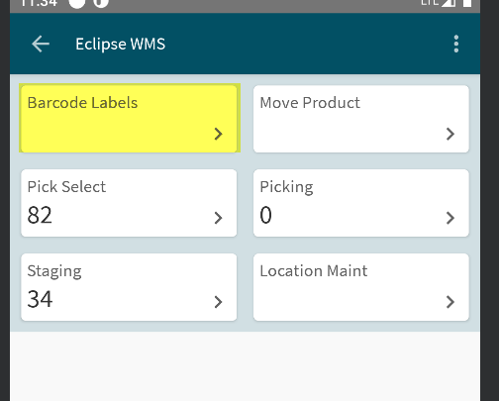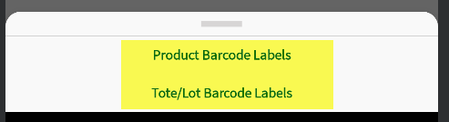
Expected Result: **Only valid RF options from WMS Override Menu are displayed and arranged as per API sort.**

Scenario 7. Verify WMS dashboard when picker is changed:

Steps to reproduce:

- Log into WMS
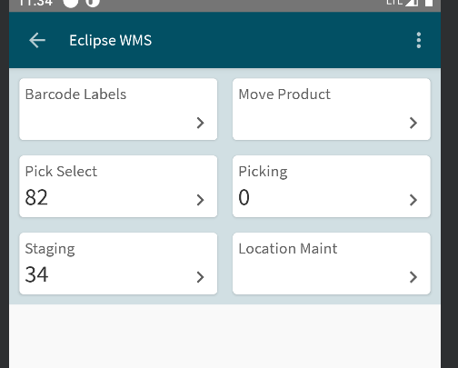
- Change the picker with a user that is using the menu from General Control File
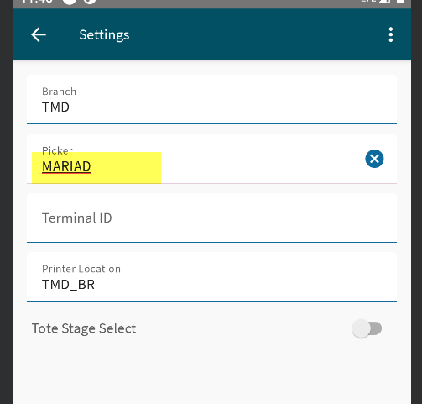
- Return to Main dashboard
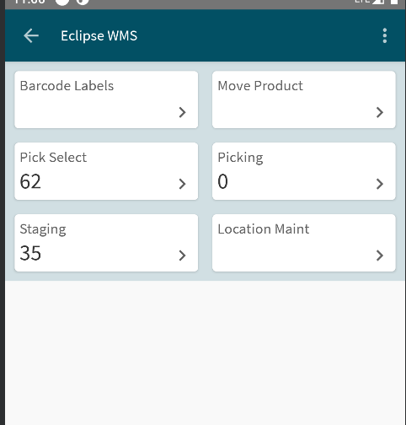
Expected Result: ** WMS Menu displayed is from logged session**

